Project Design Phase-II
Technology Stack (Architecture & Stack)

Date | 31 January 3035
Team ID
Project Name | DarshanEase
Maximum Marks | 4 Marks

Technical Architecture:
DarshanEase follows a three-tier architecture consisting of the user interface (frontend), application logic (backend), and database layer. Users interact with the system through a web-based interface built using React. The frontend communicates with the backend server through REST APIs. The backend is developed using Node.js and Express.js, which handles application logic such as user authentication, temple management, slot booking, and donation processing. The backend connects to a MongoDB database where all user data, temple details, bookings, slots, and donation information are stored. Images related to temples are managed using Cloudinary. The application can be deployed on a cloud server for better accessibility and scalability.
Example: Order processing during pandemics for offline mode
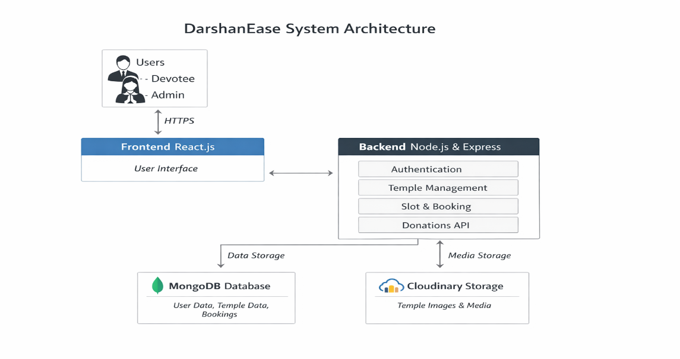

Table-1 : Components & Technologies:
S.No | Component | Description | Technology
 | User Interface | Web interface that allows users to interact with the application such as viewing temples, booking darshan slots, managing bookings, and making donations | React.js, HTML, CSS, JavaScript
 | Application Logic-1 | Handles user authentication including registration, login, and role-based access control. | Node.js, Express.js, JWT Authentication
 | Application Logic-2 | Manages temple information, darshan slot scheduling, booking management, and donation processing. | Node.js, Express.js
 | Database | Stores application data including user information, temple details, booking records, darshan slots, and donation transactions. | MongoDB (NoSQL Database)
 | File Storage | Stores temple images and other media files used in the application | Cloudinary
 | External API-1 | Cloud-based service used for storing and retrieving temple images. | Cloudinary API
 | External API-2 | The application server that hosts the backend and connects the frontend with the database. | Node.js Server, Cloud Deployment Platforms (e.g., Render, AWS, or other cloud services)

Table-2: Application Characteristics:
S.No | Characteristics | Description | Technology
 | Open-Source Frameworks | The project uses open-source frameworks for frontend and backend development. | React.js, Node.js, Express.js
 | Security Implementations | Secure authentication and authorization are implemented to protect user data and restrict access. | JWT Authentication, Password Hashing
 | Scalable Architecture | The system follows a three-tier architecture which allows separation between frontend, backend, and database, making the system easier to scale and maintain. | MERN Stack (MongoDB, Express.js, React.js, Node.js)
 | Availability | The application can be deployed on cloud infrastructure, allowing users to access the system anytime through a web browser. | Cloud Hosting Platforms
 | Performance | Efficient API communication between frontend and backend ensures faster response time and smooth user interaction. | REST APIs, Optimized Database Queries

References
1. https://c4model.com/
2. https://developer.ibm.com/patterns/online-order-processing-system-during-pandemic/
3. https://www.ibm.com/cloud/architecture
4. https://aws.amazon.com/architecture
5. https://medium.com/the-internal-startup/how-to-draw-useful-technical-architecture-diagrams-2d20c9fda90d

